**Download and Restore the Adventureworks sample databases:**

Website Link - <https://learn.microsoft.com/en-us/sql/samples/adventureworks-install-configure?view=sql-server-ver16&tabs=ssms>

Steps to follow:

1. Open Microsoft website by clicking the link above.
2. Scroll sown to the **Download backup files** section as shown below:

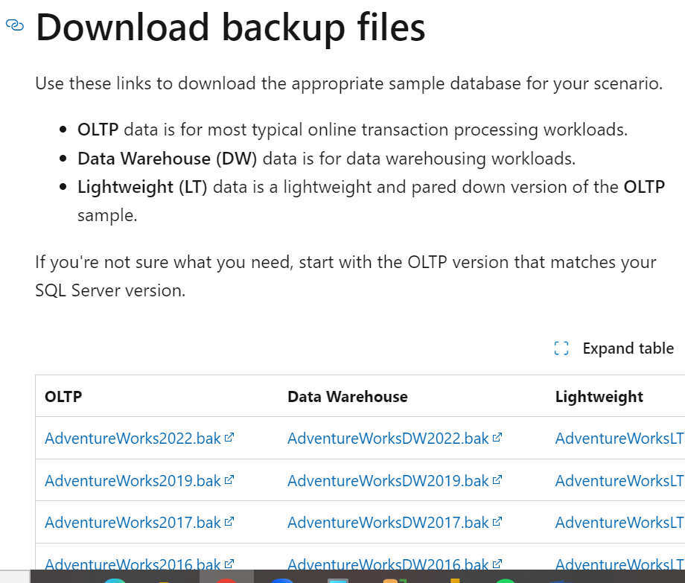

1. Click on AdventureWorks2022.bak in OLTP section.

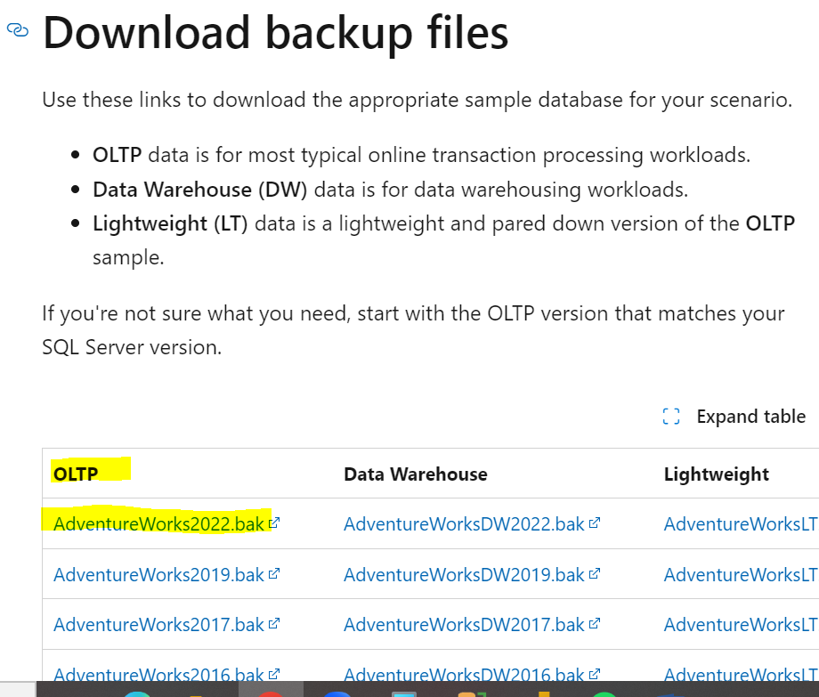

It will take around 1-2 minutes based on internet speed

1. Move the **AdventureWorks2022.bak** file to your SQL Server backup location. This location varies depending on your installation location, instance name, and version of SQL Server. For example, the default location for a default instance of SQL Server 2022 (16.x) is:

**C:\Program Files\Microsoft SQL Server\MSSQL16.MSSQLSERVER\MSSQL\Backup**

1. Open SSMS and connect to your SQL Server instance.
2. Right-click **Databases** in **Object Explorer** > **Restore Database...** to launch the **Restore Database** wizard.

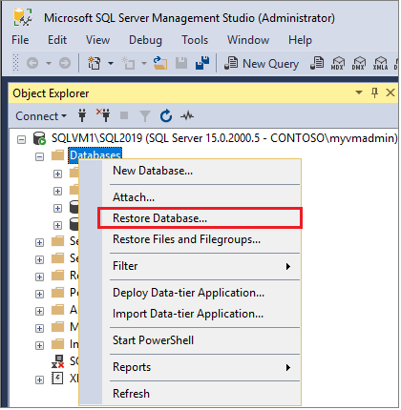

1. Select **Device** and then select the ellipses **(...)** to choose a device.
2. Select **Add** and then choose the .bak file you recently moved to the backup location. If you moved your file to this location but you're not able to see it in the wizard, SQL Server or the user signed into SQL Server doesn't have permission to this file in this folder.
3. Select **OK** to confirm your database backup selection and close the **Select backup devices** window.
4. Check the **Files** tab to confirm the **Restore as** location and file names match your intended location and file names in the **Restore Database** wizard.
5. Click OK to restore the database:

